February 2017

Dear Parents and Guardians
Form IV Parents’ Meeting

I would like to invite you to the Form IV Parents’ Meeting on Friday 10th March at 3.00pm, immediately before the girls leave for the Exeat weekend. This is an important opportunity for you and your daughter to discuss her progress with staff and we hope that as many of you as possible will attend. Tutors and Heads of House will also be available to meet with you during the course of the Parents’ Meeting.

To allow us to create an appropriate programme for you, please complete and return the slip below by Monday 20th February, or email your reply to pvsaltenburg@heathfieldschool.net

Best wishes
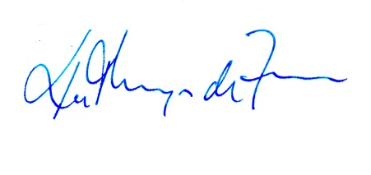
Kathryn de Ferrer
Director of Pastoral and Co-curricular Activities
------------------------------------------------------------------------------------------------------------------------
(Please return to Mrs Patrizia von Sachsen-Altenburg by Monday 20th February 2017)

Form IV Parents’ Meeting – Friday 10th March 2017 at 3.00pm

Please complete as applicable:

I/We will be able to attend the Form IV Parents’ Meeting

Name(s) of those attending:……………………………………………………………………………

I/We will not be able to attend the Form IV Parents’ Meeting

Daughter’s name:……………………………………………………………………………………….

Signature:……………………………………………………………........Date:………………………

